**LAB MANUAL**



**ROLLNO:AV.SC.U4CSE24121**

**NAME: RITHWIK G**

**SECTION: CSE-B**

**WEEK-1:**

**Aim:** How to install jdk and first program on

printing student details*.*

**Step-1:** Download JDK-21 from oracle website

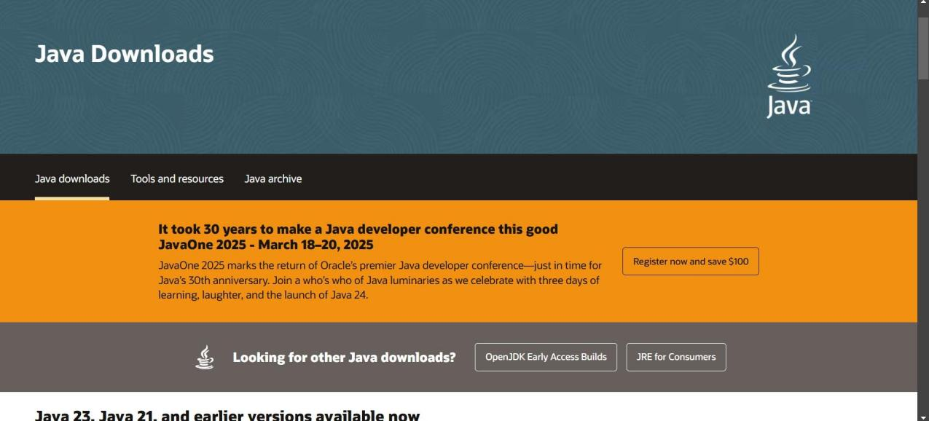

**Step-2:**Install the JDK-21 with accepting terms and

conditions according to the respective windows.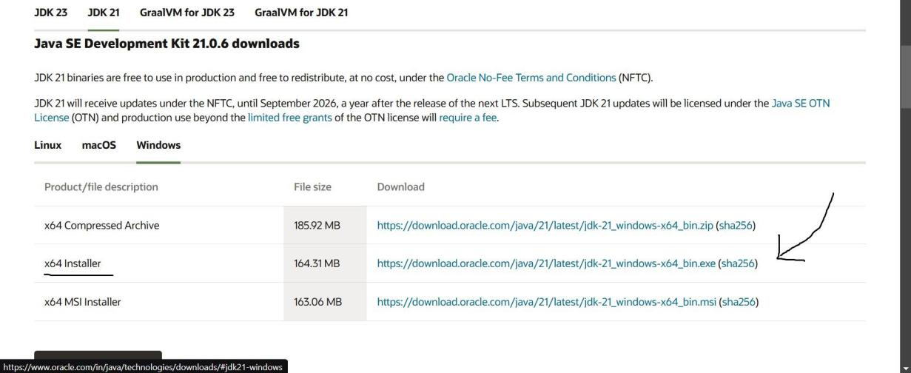

**Step-3**:Setting up environmental variables.

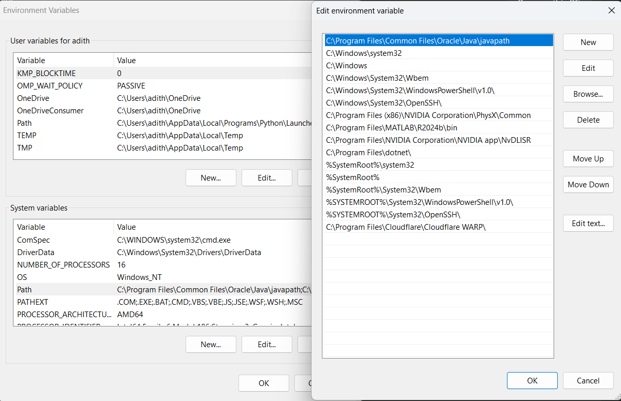

*Windows c -> C-drive -> program files ->Java -

>JDK-21->select bin

*Select and open environmental variable in search

bar-> either select system variables or user

variables-> select path-> click edit->New-> paste

the bin-> finish the setup(apply the changes).

~for verifying the installed version

Open cmd-> type java --version

~command propt

Javac filename.java ->compiling.

Java filename.java ->displaying

**PROGRAM-1(Rectified):**

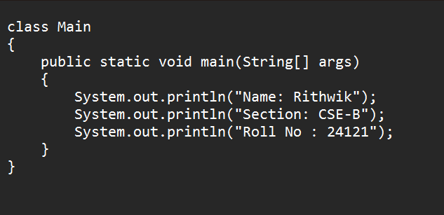

**Output:**

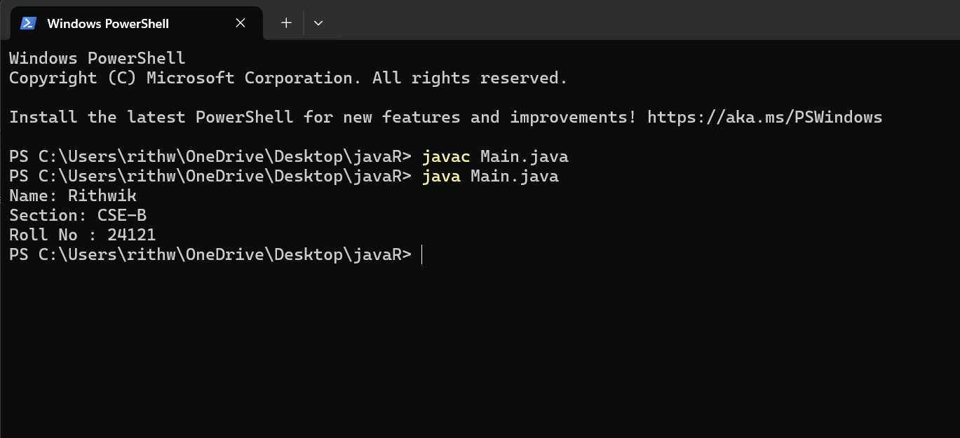

**WEEK-2:**

**PROGRAM-1:**

**Aim:**Write a java program for SI

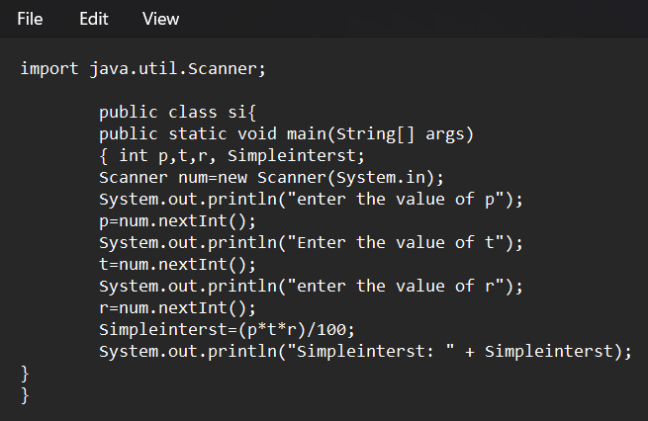

**Output:**

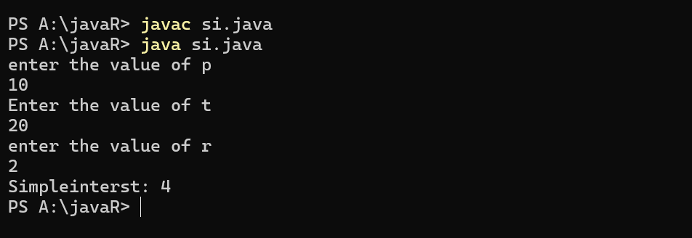

**ERROR TABLE*:***

|  |  |
| --- | --- |
| **Code Error** | **Code rectification** |
| 1.Giving space between next and Double.  2.Not giving parenthesis after closing the input. | 1.Should not give space between next and Double.  2.We must put parenthesis after closing the input. |

**PROGRAM-2:**

**Aim:**Write a program in java for area of

rectangle.

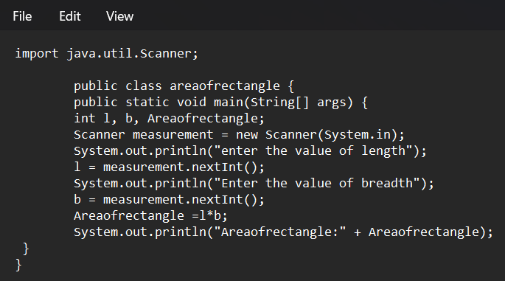

**Output:**

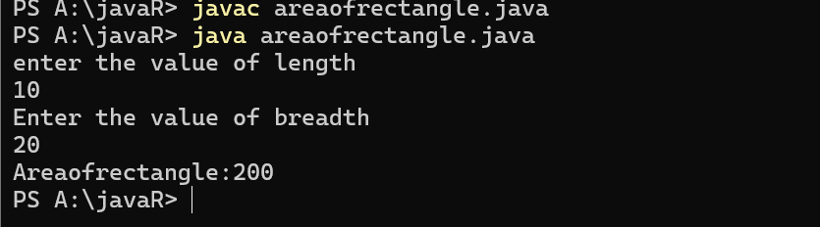

**ERROR TABLE:**

|  |  |
| --- | --- |
| **Code Error** | **Code rectification** |
| 1.While using for iteration, not giving the conditions correctly.  2.Declaring the data type as double instead of int. | 1.We should give iterative statements correctly.  2.We should give the data type as int for integers. |

**PROGRAM-3:**

**Aim:**Write a program in java for area of triangle using heron’s formula.

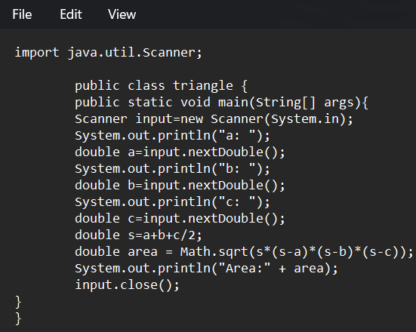

**Output:**

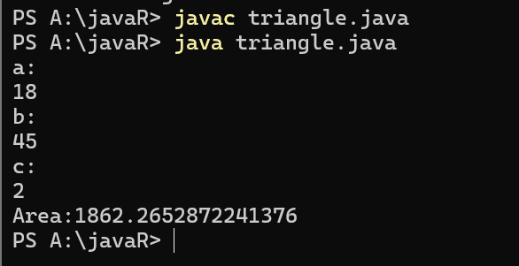

ERROR TABLE:

|  |  |
| --- | --- |
| **Code Error** | Code rectification |
| 1.While printing the variable not giving + sign.  2.Not closing the scanner. | 1.We should give correct indentation.  2.Closing the scanner is must. |

**PROGRAM-4(a):**

**Aim:**Write a program in java for converting temperature from celsius to fahrenite.

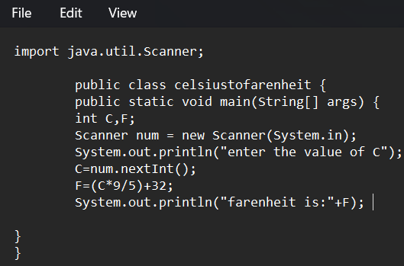

OUTPUT:

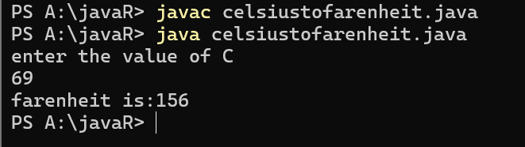

**PROGRAM-4(b):**

**Aim:**Write a program in java for converting temperature from fahrenite to celsius.

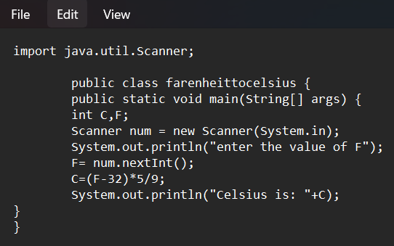

**Output:**

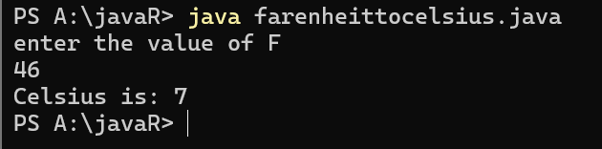

**ERROR TABLE:**

|  |  |
| --- | --- |
| **Code Error** | **Code rectification** |
| 1.While printing the variable not giving + sign.  2.Not closing the scanner. | 1.We should give correct indentation.  2.Closing the scanner is must. |

**PROGRAM-5:**

**Aim:**Write a program in java for factorial of a number.

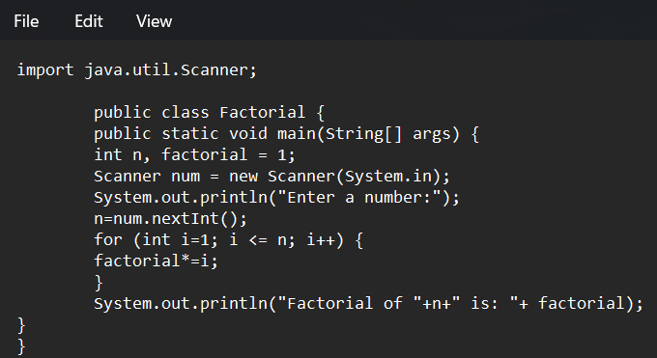

OUTPUT:

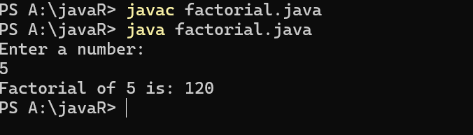

ERROR TABLE:

|  |  |
| --- | --- |
| **Code Error** | **Code rectification** |
| 1.While using for iteration, not giving the conditions correctly.  2.Declaring the data type as double instead of int. | 1.We should give iterative statements correctly.  2.We should give the data type as int for integers. |

**PROGRAM-6:**

**Aim:**Write a program in java for fibonacci series.

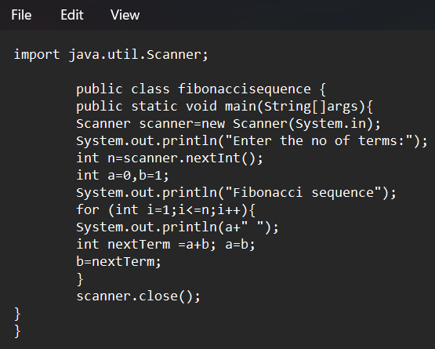

OUTPUT:

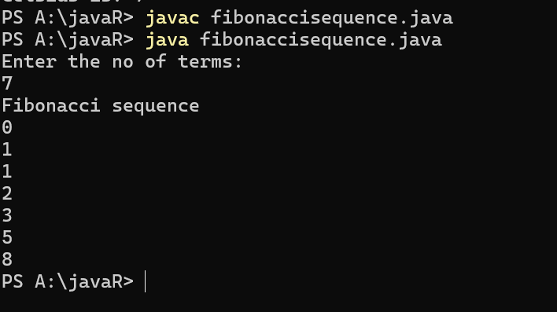

ERROR TABLE:

|  |  |
| --- | --- |
| **Code Error** | **Code rectification** |
| 1.Giving space between next and Double.  2.Not giving parenthesis after closing the input. | 1.Should not give space between next and Double.  2.We must put parenthesis after closing the input. |

**WEEK -3:**

**PROGRAM-1:**

**AIM:** To create java program with following instructions :

1.Create a class with name Car

2.Create four attributes named car_color,car_brand, fuel_type, mileage

3.Create these methods named start(),stop(),service()

4.Create the objects named car, car1,car2

**CODE:**

public class Car {

private String car_color;

private String car_brand;

private String fuel_type;

private String mileage;

public void start() {

System.out.println("car is started");

}

public void stop() {

System.out.println("car is stopped");

}

public void service() {

System.out.println("car is for service");

}

public static void main(String args[]) {

Car car = new Car();

car.car_color = "white";

car.car_brand = "audi";

car.fuel_type = "petrol";

car.mileage = "20";

car.start();

System.out.println("car_color: " + car.car_color + " car_brand: " + car.car_brand + " fuel_type: " + car.fuel_type + " mileage: " + car.mileage);

Car car1 = new Car();

car1.car_color = "white";

car1.car_brand = "audi";

car1.fuel_type = "petrol";

car1.mileage = "20";

car1.stop();

System.out.println("car_color: " + car1.car_color + " car_brand: " + car1.car_brand + " fuel_type: " + car1.fuel_type + " mileage: " + car1.mileage);

Car car2 = new Car();

car2.car_color = "white";

car2.car_brand = "audi";

car2.fuel_type = "petrol";

car2.mileage = "20";

car2.service();

System.out.println("car_color: " + car2.car_color + " car_brand: " + car2.car_brand + " fuel_type: " + car2.fuel_type + " mileage: " + car2.mileage);

}

}

**OUTPUT:**

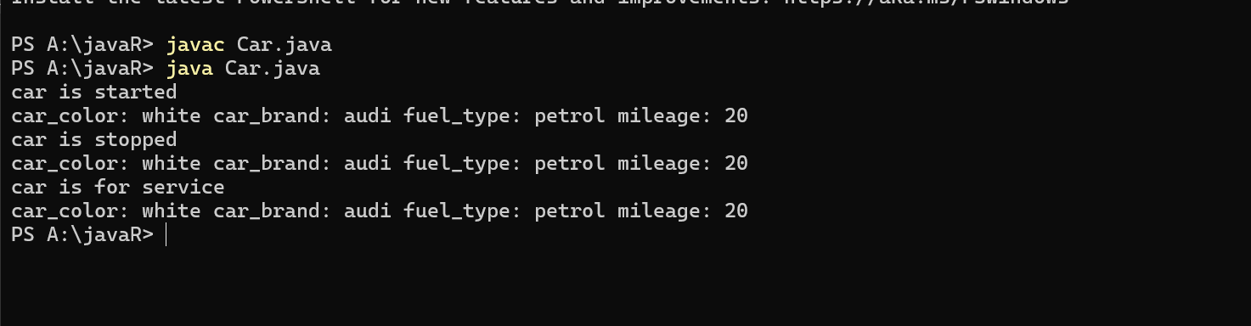

**Error table:**

|  |  |  |  |
| --- | --- | --- | --- |
| S.no | Error name | Cause of error | Rectification |
| 1 | Syntax Error | Missing ‘{‘ | ‘{‘ added |
| 2 | Compile time Error | Mispelled Variable call | Rectified with  Correct variable name |
| 3 | Case sensitive error | Uppercase and lowercase | rectified |

**Class diagram:**

|  |
| --- |
| **car**  **----------------------**-  -car_color:string  -car_brand:string  -fuel_type:string  -milage:double  ----------------------  +start():void  +stop():void  +service():void |

**PROGRAM-2:**

**Aim:** To create a class BankAccount with methods deposit() and withdraw() . create two subclasses savingsaccount and checkingaccount override the withdraw () method in each subclass to impose different withdrawal limits and fees

public class BankAccount {

protected String accountHolder;

protected double balance;

protected int accountNumber;

public BankAccount(String accountHolder, int accountNumber, double balance) {

this.accountHolder = accountHolder;

this.accountNumber = accountNumber;

this.balance = balance;

}

public void withdrawal(double amount) {

if (amount <= balance) {

balance = balance - amount;

System.out.println("Current balance: " + balance);

} else {

System.out.println("Insufficient funds");

}

}

public void deposit(double amount) {

balance = balance + amount;

System.out.println("Current balance: " + balance);

}

public static void main(String[] args) {

BankAccount BA = new BankAccount("Abdul", 24248, 1000);

BA.withdrawal(500);

BA.deposit(1500);

}

}

**OUTPUT:**

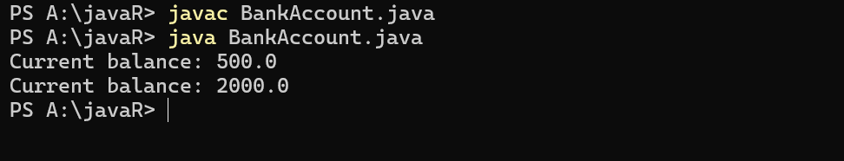

**Error table:**

|  |  |  |  |
| --- | --- | --- | --- |
| S.no | Error name | Error name | Rectification |
| 1 | Name Error | Undefined name | Correct variable  Name replaced |
| 2 | Syntax Error | Missing Parenthesis | Parenthesis Added |
| 3 | Logical Error | Incorrect Condition | Condition Rectified |

**Class diagram:**

|  |
| --- |
| **BankAccount**  ----------------------------------------------------------  -balance: double  ----------------------------------------------------------  +BankAccount(intialBalance: double)  +deposit(amount: double):void  +withdraw(amount: double):void |